FIND SUPPORT. GET SUPPORT. GIVE SUPPORT
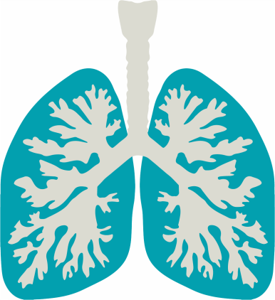
Tulane Pulmonary Fibrosis Support Group

TOPIC: LUNG TRANSPLANTATION
WHEN: Wednesday, March 15th
11am to 1pm (CST)
WHERE: Tulane Medical Center Conference Room, Room 7206
(Wheelchairs and Valet Parking available)
ZOOM OPTION AVAILABLE
Email Questions and request Zoom link to: pfsupport@tulane.edu
If you or a loved one has been affected by pulmonary fibrosis, you are invited to attend our support group. Participating in a support group may improve your emotional well-being and have a positive impact on your health by offering you an opportunity to connect with others who facing similar experiences, obtain practical information, and to receive support. Support groups can also be a valuable resource for your caregivers, other family members, and friends. Please remember, a support group should not replace treatment from your doctor. For more information about pulmonary fibrosis, visit pulmonaryfibrosis.org
Scan QR code with device to subscribe to Tulane PF Support Group mailing list.

