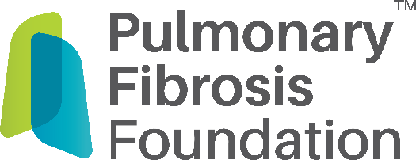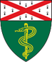

**Pulmonary Fibrosis Patient Support Group**

**Keep It Moving**

**Staying Active While Living with Chronic Lung Disease**

**Wednesday, August 21, 2023**

**3:00 pm – 4:00 pm**

RSVP appreciated but not required by August 19, 2023 at [ILDINFO@yale.edu](mailto:ILDINFO@yale.edu)

This event is supported by the Pulmonary Fibrosis Foundation & the Yale Interstitial Lung Disease Center of Excellence

**Zoom:** [https://yale.zoom.us/j/4404527095?pwd=WXhQUkVDV1kzV1BiOXZPczRYRk9OQT09&omn=92409481561](https://urldefense.com/v3/__https:/yale.zoom.us/j/4404527095?pwd=WXhQUkVDV1kzV1BiOXZPczRYRk9OQT09&omn=92409481561__;!!G9aKEII32E6ngQ!LMtLHwxw1GpY8ZDmBnrRGxNi_v6HyDoGhohuTgdx6w1JJBnkgoixOZbvhP9LQ9HD-sF82Hr6eL1XbfPYRKqpXlDF2wGff_IBOQ$)

**Meeting ID:** 440 452 7095 **Passcode:** 765675